**Diagnostic Tool for STC-1XX Design**

|  |  |  |  |
| --- | --- | --- | --- |
| Objective: |  | | |
| Author: | Evan Hsu | Release Date: | Jun-29th-2012 |
| E-mail: | ehsu2@visteon-jv.com | Program: | Diagnostic Tool for STC-1XX |
| Area: | CCVECS, China | Revision #: | 01 |
| Report used for:  (Visteon internally or Released to Customer) |  | | |

Table of Contents

1. Introduction 4

1.1 Purpose 4

1.2 Scope 4

1.3 Reference(s) 4

1.4 Acronyms 4

1.5 Document Overview 4

2. Design Constraints 4

2.1 Environment 4

2.2 Hardware 5

2.3 Software 5

2.4 Design Reuse 5

3. User Interface 5

3.1 System Diagnostic Tool 5

3.2 Read Engine Parameter 6

3.3 Freeze Frame Data 7

3.4 Self-Test 7

3.5 System Status 8

3.6 Input/Output Test 8

3.7 Vehicle Information 9

4. High Level Design 9

4.1 Top Level 9

4.2 Sub Modules 10

4.2.1 System Diagnostic Tools 10

4.2.2 Read Engine Parameter 11

4.2.3 Freeze Frame Data 12

4.2.4 Self-Test 13

4.2.5 System Status 14

4.2.6 Input/Output Test 15

4.2.7 Vehicle Information 16

5. Revision History 17

6. Originator of This Document 17

# Introduction

## Purpose

The purpose of this document is to describe the software design of the Diagnostic Tool for STC-1XX.

## 1.2 Scope

This document describes the software design of the Diagnostic Tool, which consists of 7 main parts: System Diagnostic Tool, Read Engine Parameter, Freeze-Frame Data, Self-Test, System Status, Input/Output Test and Vehicle Information.

## 1.3 Reference(s)

|  |  |
| --- | --- |
| 1. | VC_CBseries_Part_II_Specification_Rev5_021108 |
| 2. | saeJ1979_2006-08-25Ballot |

## 1.4 Acronyms

|  |  |
| --- | --- |
| Acronyms | Definition |
| NVM | Non Volatile Memory |
| ECU | Engine Control Unit |
| KAM | Keep Alive Memory |
| VI | Virtual Instruments |
| DTC | Diagnostic Trouble Code |
| HEGO | Heated Exhaust Gas Oxygen Sensor |
| KOEO | Key-On-Engine-Off |
| KOER | Key-On-Engine-Running |

## 1.5 Document Overview

This document is broken down into 3 main parts for describing the Diagnostic Tool Software. The first part is the Design Constraints, described in section 2. The second part is the User Interface in section 3. The last part of the software description is the High Level Design detailed in section 4.

# Design Constraints

## Environment

The software can only be run in a Microsoft Windows Operating System. Versions known to be supported are: Windows XP, Windows Vista, and Windows 7.

## 2.2 Hardware

There is only one hardware component required for connecting the PC to ECU. This is accomplished using the K-line connector through USB interface.

## 2.3 Software

LabView 8.5 will be used to create the Diagnostic Tool Software for STC-1XX.

## 2.4 Design Reuse

Three LabView VIs are reused in creating the Diagnostic Tool Software. The 3 VIs are:

1. “Select Serial Port.VI”
2. “Serial Init.VI”
3. “Serial Write and Read.VI”

# User Interface

This section of the document will detail the top layer User Interface that the user will encounter when using the Diagnostic Tool for STC-1xx. User Interface description is divided into 7 parts: System Diagnostic Tool, Read Engine Parameter, Freeze-Frame Data, Self-Test, System Status, Input/Output Test and Vehicle Information.

## System Diagnostic Tool

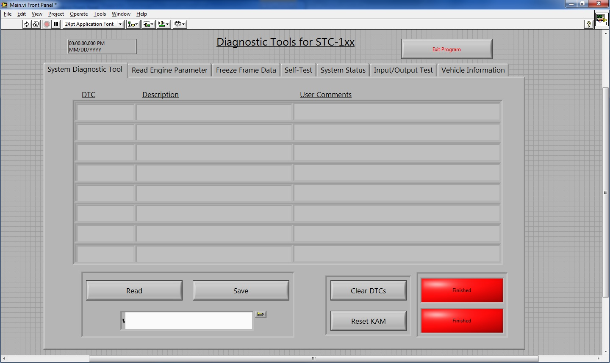

3.

2.

1.

1. DTC Table – A table that lists all the DTCs within the ECU. The first column lists the DTC number, second column gives the description of the DTC, and the third column is for the user to add comments to the DTCs listed.
2. DTC Read Control Box – Pressing the “Read” button, reads in the DTCs in the ECU which are then displayed in the DTC Table. The user can also specify a file location to save DTC information in a excel file.
3. Clear DTCs & Reset KAM – This control box contains 2 functions. The first is the “Clear DTC” function which clears all DTCs in the ECU’s NVM. The second function is “Reset KAM”, which is used to reset the Keep Alive Memory on the ECU.

## Read Engine Parameter

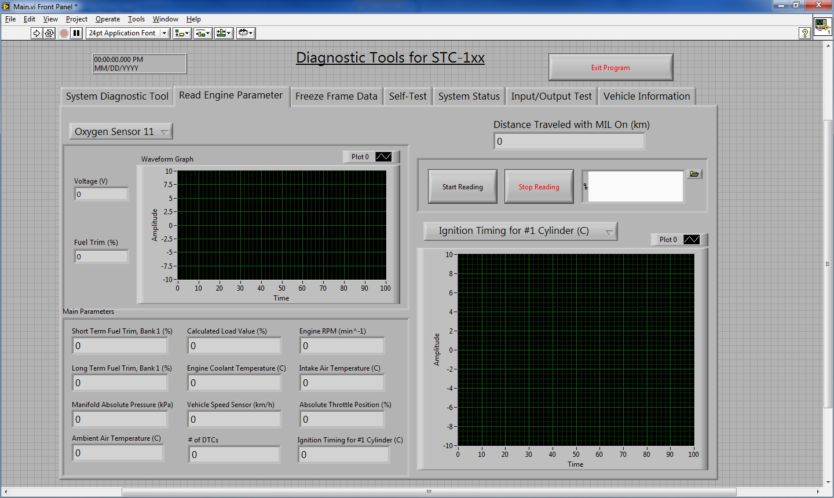

5.

4.

3.

2.

1.

1. HEGO Sensor Data – Allows the user to view the Voltage, Fuel Trim (%) and a Voltage Waveform Graph of either Oxygen Sensor 11 or Oxygen Sensor 12.
2. Read Engine Parameter Control – The user controls when to start reading in engine parameters and when to stop reading engine parameters. The user can also specify a location to store parameter data in an excel file.
3. Distance Traveled with MIL on – Displays the Distance Traveled with Malfunction Indicator Light on in Kilometers.
4. Main Parameters – Displays the live main parameter data.
5. Parameter Waveform – Displays a waveform graph of any of the main parameters in #4 of Read Engine Parameter.

## Freeze Frame Data

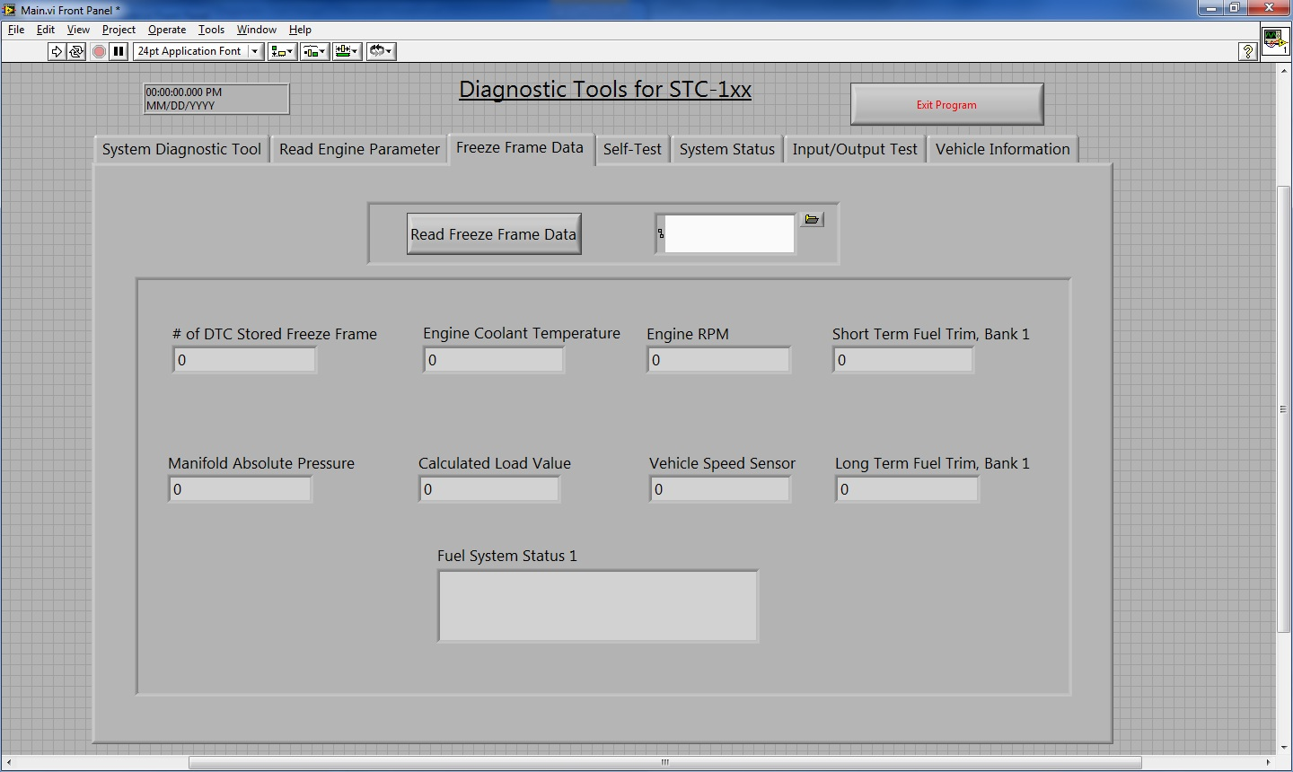

1.

2.

1. Freeze Frame Data Control – The User Controls when to read Freeze Frame Data, which will automatically be stored in an excel file the user specifies.
2. Freeze Frame Data – Displays the live Freeze Frame Data

## Self-Test

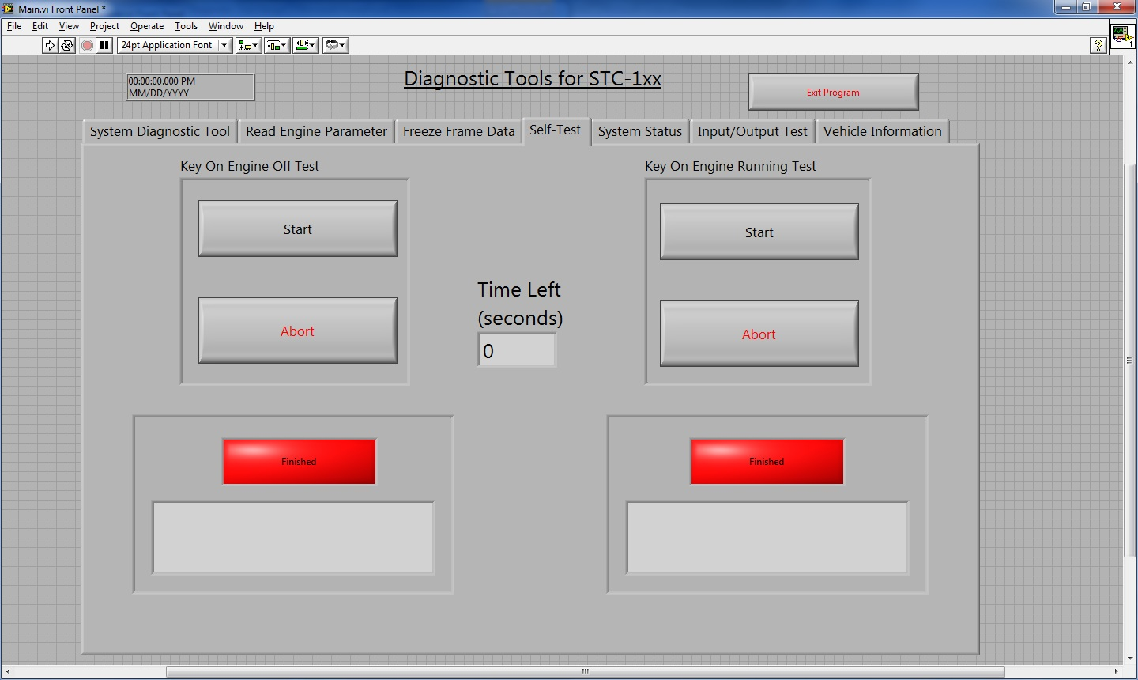

1.

2.

3.

1. KOEO Test – The user controls when to start the KOEO Test and can abort if needed. There are two indicators that let the user know when the test is finished and if the KOEO test is successful.
2. KOER Test – The user controls when to start the KOER Test and can abort if needed. There are two indicators that let the user know when the test is finished and if the KOER test is successful.
3. Time Left – Displays the time in seconds left until either the KOEO Test or the KOER test is complete.

## System Status

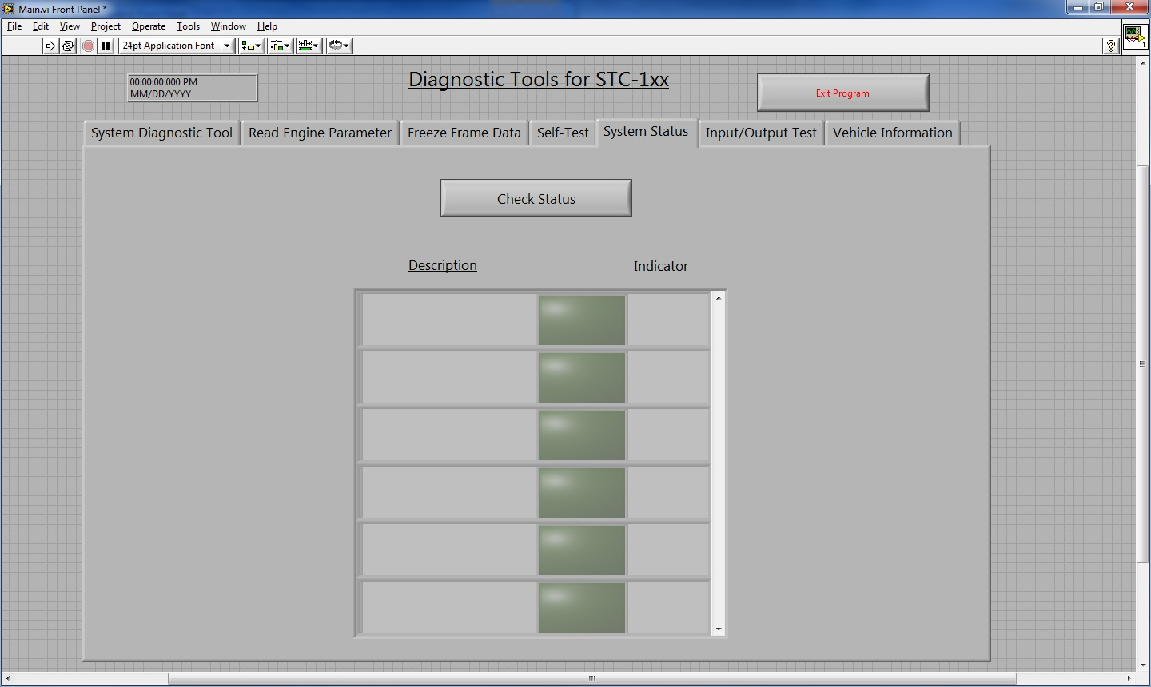

1.

1. System Status – The user can control when to start checking the status of the vehicle. The data is displayed in a scroll down table. The first column indicates the component of the vehicle. The second column is a Boolean indicator which illuminates when a vehicle component on. The third column a text indicator that will simply display either “ON” or “OFF”

## Input/Output Test

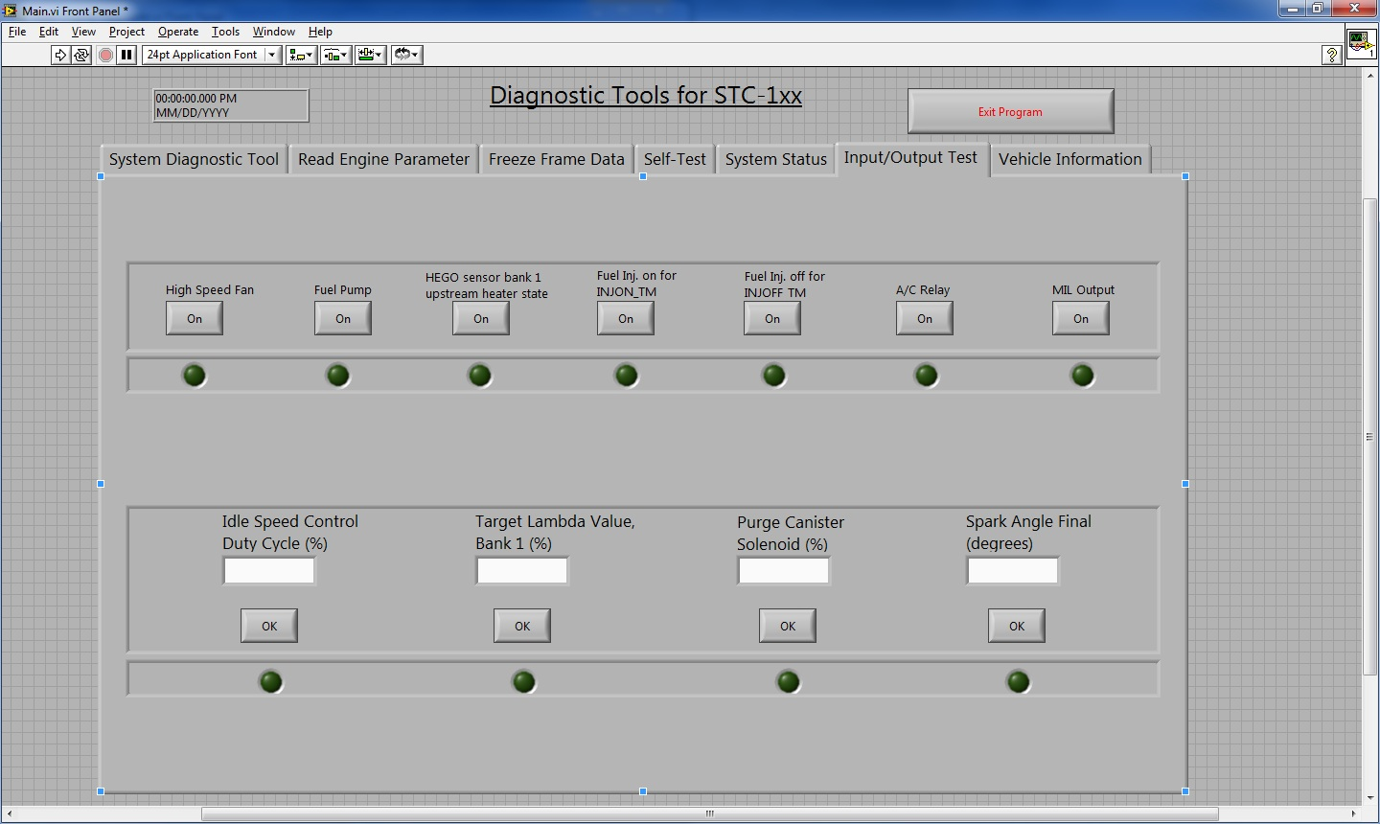

2.

1.

1. Control Switch – Allows the user to turn on and off different components of the car.
2. Value control – Allows the user to input a desired value for certain car components.

## 3.7 Vehicle Information

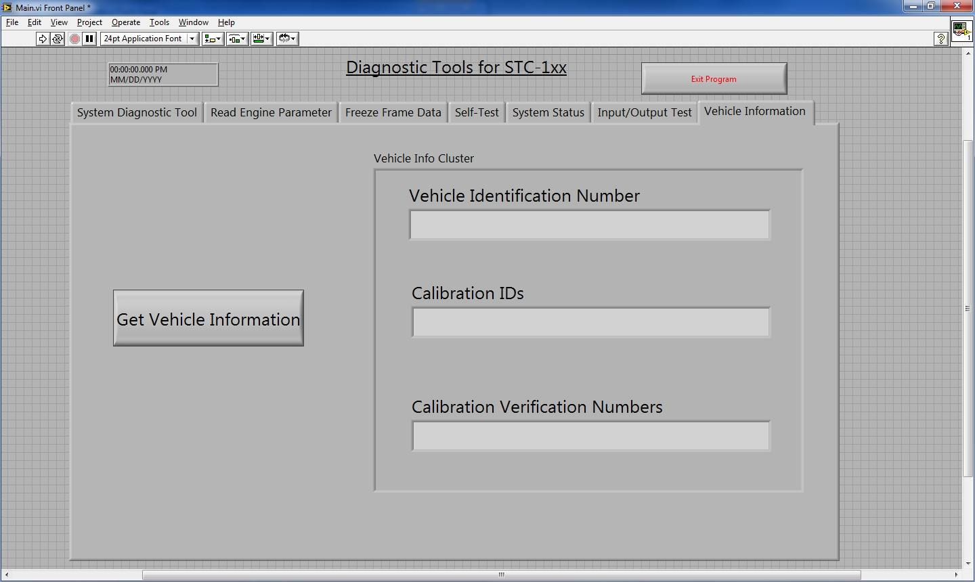

1.

1. Vehicle Information Display – Displays the Vehicle Identification Number, Calibration IDs and Calibration Verification Numbers when the user selects the “Get Vehicle Information” Button.

# 4. High Level Design

## 4.1 Top Level

The top level of the program is designed in a tab based style to separate the 7 main parts: System Diagnostic Tool, Read Engine Parameter, Freeze-Frame Data, Self-Test, System Status, Input/Output Test and Vehicle Information. Each part of the program operates independently from each other, and only operates depending on which of the 7 tabs the user selects.

> Tab Select

Sys. Diag. Tool Output Cluster <

> Sys. Diag. Tool Input Cluster

Read Eng. Param. Output Cluster <

> Read Eng. Param. Input Cluster

Freeze Frame Data Output Cluster <

> Freeze Frame Data Input Cluster

Self-Test Output Cluster <

> Self-Test Input Cluster

> System Status Input Cluster

System Status Output Cluster <

Input/Output Test Output Cluster <

> Input/Output Test Input Cluster

> Vehicle Info Input Cluster

Vehicle Info Output Cluster <

The top layer finite state machine consists of 3 parts: input, output, and sub modules. 7 sub modules exist to satisfy the 7 operations in which the program consists of. Below is a depiction of how the top finite state machine is laid out:

Sys. Diag. Tool Input Cluster

Read Eng. Param. Input Cluster

System Status Input Cluster

Input/Output Test Input Cluster

Vehicle Info Input Cluster

Freeze Frame Data Input Cluster

Self-Test Input Cluster

Sys. Diag. Tool Output Cluster

Read Eng. Param. Output Cluster

System Status Output Cluster

Input/Output Test Output Cluster

Vehicle Info Output Cluster

Freeze Frame Data Output Cluster

Self-Test Output Cluster

Tab Select

Sys. Diag. Tool Sub

Read Eng. Param. Sub

Freeze Frame Data Sub

Self-Test Sub

System Status Sub

Input/Output Test Sub

Vehicle Info Sub

## 4.2 Sub Modules

### 4.2.1 System Diagnostic Tools

Sys. Diag. Tool Sub

> IO Device

> Read DTC Buttons

> Diagnostic Buttons

DTC Table <

Diagnostic Indicator <

The purpose of the System Diagnostic Tool Sub Module is to produce 4 functions:

1. Read DTCs
2. Clear DTCs
3. Reset KAM
4. Store DTC’s in an worksheet file

Inputs

* IO Device – The port the PC uses to connect to the ECU
* Read DTC Buttons – A cluster of inputs including “Read” DTC button, “Save” button and a file path input for saving an excel file of DTC data.
* Diagnostic Buttons – A cluster of two buttons: “Clear DTC” and “Reset KAM”.

Outputs

* DTC Table – The table that lists all DTCs in the ECU.
* Diagnostic Indicator – Outputs two Boolean lights. One corresponds to the status of the “Clear DTC” function and the other Boolean light corresponds to the status of the “Reset KAM” Function.

### 4.2.2 Read Engine Parameter

Read Engine Parameter

>IO Device

> Parameter Ring

> Oxygen Sensor Ring

> Parameter Control

Oxygen Sensors <

Parameter Waveform <

Main Parameters <

Distance Traveled with MIL On <

The purpose of the Read Engine Parameter Sub Module is to:

1. Read in Main Parameters *(See Table 4.2.2 for list)*
2. Display HEGO Sensor data in a waveform graph
3. Display Main Parameter data in a waveform graph
4. Display a vehicle’s Distance Traveled with MIL on
5. Save parameter data in an excel file

Inputs

* IO Device – The port the PC uses to connect to the ECU
* Parameter Ring – A selection ring to choose which Main Parameter will be displayed in the Parameter Waveform.
* Oxygen Sensor Ring – A selection ring to choose which HEGO sensor to be displayed in the Oxygen Sensor Waveform.
* Parameter Control – A cluster of inputs containing the “Start Reading”, “Stop Reading” buttons and an input box to specify where parameter data should be stored.

Outputs

* Oxygen Sensors – a cluster of outputs containing a waveform graph, Voltage indicator and Fuel Trim (%) indicator.
* Parameter Waveform – A waveform for displaying a selected main parameter.
* Main Parameters – Multiple Indicators for displaying parameter data.
* Distance Traveled with MIL on – A Double indicator for displaying the Distance Traveled with MIL on.

#### Table 4.2.2

|  |  |  |  |  |
| --- | --- | --- | --- | --- |
| PID | Description | Units | Range | Data Bytes |
| $01 | Number of DTCs | # | 0 to 127 | A |
| $03 | Fuels System 1 Status | Message | N/A | A |
| $04 | Calculated Load Value | % | 0 to 100 | A |
| $05 | Engine Coolant Temperature | oC | -40 to 215 | A |
| $06 | Short Term Fuel Trim, Bank 1 | % | -100 to 99.22 | A |
| $07 | Long Term Fuel Trim, Bank 1 | % | -100 to 99.22 | A |
| $0B | Intake Manifold Absolute Pressure | kPa | 0 to 255 | A |
| $0C | Engine RPM | Min-1 | 0 to 16383.75 | A, B |
| $0D | Vehicle Speed Sensor | Km/h | 0 to 255 | A |
| $0E | Ignition Timing Advance for #1 Cylinder | Degree | -64 to 63.5 | A |
| $0F | Intake Air Temperature | oC | -40 to 215 | A |
| $11 | Absolute Throttle Position | % | 0 to 100 | A |
| $14 | Oxygen Sensor 11 Voltage/Fuel Trim. | V, % | 0 to 1.275, -100 to 99.22 | A, B |
| $15 | Oxygen Sensor 12 Voltage/Fuel Trim. | V, % | 0 to 1.275, -100 to 99.22 | A,B |
| $21 | Distance Traveled with MIL on | Km | 0 to 65535 | A, B |
| $46 | Ambient Air Temperature (Calc) | oC | -40 to 215 | A |

### Freeze Frame Data

Freeze Frame Data Sub

> IO Device

> Freeze Frame Control

Freeze Frame Cluster <

The purpose of the Freeze Frame Data Sub Module is to:

1. Read in Freeze Frame Data from the ECU *(See Table 4.2.3 for Freeze Frame Data list)*
2. Store the read Freeze Frame Data into a worksheet file

Inputs

* IO Device - The port the PC uses to connect to the ECU.
* Freeze Frame Control – A cluster of the “Read Freeze Frame Data” button and an input box to specify where the freeze frame data is saved.

Outputs

* Freeze Frame Cluster – A cluster of indicators that display the freeze frame data on the ECU.

#### Table 4.2.3

|  |  |  |  |  |
| --- | --- | --- | --- | --- |
| PID | Description | Units | Range | Data Bytes |
| $02 | DTC stored by freeze Frame | Hex | 00 00 to FF FF | A,B |
| $03 | Fuel System Status 1 | String | N/A | A |
| $04 | Calculated Load Value | % | 0 to 100 | A |
| $05 | Engine Coolant Temperature | oC | -40 to 215 | A |
| $06 | Short Term Fuel Trim, Bank 1 | % | -100 to 99.2 | A |
| $07 | Long Term Fuel Trim, Bank 1 | % | -100 to 99.22 | A |
| $0B | Intake Manifold Absolute Pressure | kPa | 0 to 255 | A |
| $0C | Engine RPM | Min-1 | 0 to 16383.75 | A,B |
| $0D | Vehicle Speed Sensor | Km | 0 to 255 | A |

### Self-Test

Self-Test Sub

>IO Device

> KOEO Test

> KOER Test

KOEO Test Indicator <

KOER Test Indicator <

Time Left <

The purpose of the Self-Test Sub is to:

1. Run a Key-On-Engine-Off Test
2. Run a Key-On-Engine-Running Test
3. Display the time left on the current test running

Inputs

* IO Device - The port the PC uses to connect to the ECU.
* KOEO Test – A cluster of the “Start” and “Abort” buttons. Used for controlling the KOEO test.
* KOER Test – A cluster of the “Start” and “Abort” buttons. Used for controlling the KOER test.

Outputs

* KOEO Test Indicator – A cluster of a Boolean light indicator and a status box displaying if the KOEO test ran successfully.
* KOER Test Indicator – A cluster of a Boolean light indicator and a status box displaying if the KOER test ran successfully.
* Time Left – a Double indicator that displays the time left in seconds of either the KOEO test or the KOER test.

### System Status

System Status Sub

>IO Device

> Check Status

Status Array <

The purpose of the System Status Sub Module is to Display the live status of various vehicle components

*(See Table 4.2.5 for a list of vehicle components).*

Inputs

* IO Device - The port the PC uses to connect to the ECU.
* Check Status – A button used to initiate reading the system status

Outputs

* Status Array – An array of clusters that display various vehicle components along with the status of each of those components.

#### Table 4.2.5

|  |  |  |
| --- | --- | --- |
| Common ID # | Description | Byte/Bit |
| 0906 | Control state of the hardwired AC input pin to the PCM | 1/7 |
| 095D | Idle Air Monitor Completed | 1/7 |
| 095D | Misfire Monitor Completed | 2/7 |
| 095D | EGR monitor Completed | 2/6 |
| 095D | HEGO Monitor Completed | 2/5 |
| 095D | Fuel Monitor Completed | 2/4 |
| 095D | Secondary Air Monitor Completed | 2/3 |
| 095d | Purge Monitor Completed | 2/2 |
| 095D | CCM Monitor Completed | 2/1 |
| 095D | Catalyst Monitor Completed | 2/0 |
| 09CD | CMP and CKP are in sync | 1/0 |
| 09CD | PIP state is high | 1/2 |
| 09CD | Dechoke mode flag | 1/3 |
| 1101 | Power Steering Pressure Switch load present | 1/7 |
| 1101 | A/C requested by driver | 1/0 |
| 1102 | A/C pressure sensor high | 1/0 |
| 1103 | OBDII trip completed | 1/7 |
| 1103 | Open Loop Fuel conditions met | 1/6 |
| 1103 | MIL requested on | 1/5 |
| 1103 | High Speed Fan requested on | 1/3 |
| 1104 | A/C clutch commanded on | 1/0 |
| 1106 | IAT failure mode | 1/7 |
| 1106 | ECT failure mode | 1/6 |
| 1106 | Throttle Sensor Failure Mode | 1/5 |
| 1107 | 1 = OSS is in FMEM | 1/1 |
| 1107 | 1=CID is not currently reliable | 1/0 |
| 162D | Injector #4 Output fault detected | 1/3 |
| 162D | Injector #3 Output fault detected | ½ |
| 162D | Injector #2 Output fault detected | 1/1 |
| 162D | Injector #1 Output fault detected | 1/0 |
| 162E | A/C Clutch output fault detected | 1/5 |
| 162F | High Speed Fan Output fault detected | 1/1 |
| 1631 | O2S Heater 11 State | 1/0 |
| A430 | Coolant temperature has reached OBDII warm threshold | 1/1 |
| A430 | On/Run | 1/0 |

### Input/Output Test

Input/Output Test Sub

> IO Device

> Control 1

> Control 2

Control Lights 1 <

Control Lights 2 <

The purpose of the Input/Output Test Sub Module is to control different components of the vehicle *(See Table 4.2.6 for a list of Input/Output Tests)*

Inputs

* IO Device - The port the PC uses to connect to the ECU.
* Control 1 – A cluster of buttons which can turn various vehicle components On or Off.
* Control 2 – A cluster of buttons and input boxes used to control specific vehicle components using a user specified value.

Outputs

* Control Lights 1 – A cluster of Boolean light indicators that illuminate when a corresponding vehicle component is active. Control Lights 1 corresponds with the Control 1 inputs.
* Control Lights 2 – A cluster of Boolean light indicators that illuminate when a corresponding Control 2 buttons are selected to indicate that the vehicle component is being controlled with the specified value.

#### Table 4.2.6

|  |  |  |
| --- | --- | --- |
| Common ID # | Hex Channel # | Description |
| E900 | 00 | Idle speed control duty cycle |
| E904 | 04 | Target lambda value, bank 1 |
| E906 | 06 | Fuel pump commanded on/off |
| E909 | 09 | Purge Canister Solenoid |
| E911 | 11 | Spark angle final |
| E919 | 19 | HEGO sensor bank 1 upstream heater state |
| E91D | 1D | Command Specified Fuel injectors on for INJON_TM |
| E91E | 1E | Command specified fuel injectors off for INJOFF_TM |
| E941 | 41 | A/C Relay |
| E942 | 42 | MIL Output |
| E952 | 52 | High Speed Fan Commanded On |

### 4.2.7 Vehicle Information

Vehicle Information Sub

> IO Device

> Vehicle Info Button

Vehicle Info Cluster <

The purpose of the Vehicle Information Sub is to output:

1. Vehicle Identification Number
2. Calibration IDs
3. Calibration Verification Number

Inputs

* IO Device - The port the PC uses to connect to the ECU.
* Vehicle Info Button – A Boolean button to request for Vehicle Information

Output

* Vehicle Info Cluster – A cluster of string indicators that display the Vehicle Identification Number, Calibration IDs and Calibration Verification Number.

# Revision History

|  |  |  |  |
| --- | --- | --- | --- |
| Revision Level | Section/Page | Date | Description |
| 1.0 | All | 6/19/2012 | Initial Release |

# Originator of This Document

Evan Hsu

E-mail: [ehsu2@visteon-jv.com](mailto:ehsu2@visteon-jv.com)

Department: Product Development Changan Visteon